Food “Drive”

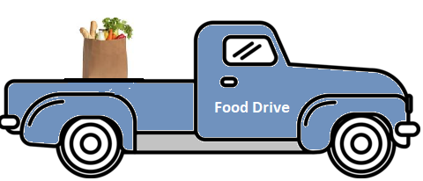

Food “drive” scavenger hunt benefiting the Center’s Food Bank

=====================
Participants will receive a list of places to drive, scan a QR code for a clue, and then use your registration sponsorship to purchase food items
=====================

When: April 6th
Start Time: Choose 10:00 or 11:00
Starting From: Peace Church, Berrysburg
What You Need: Car and Smart Phone
Registration/Sponsorship: $20.00 per car
To Register* or for More Information:
UDhumanservices@gmail.com / 717-453-9352
*Registration is encouraged, but not required

Hosted by: Peace & St. Peter’s Churches

